Click the link in the email that was sent to you to begin the registration process.

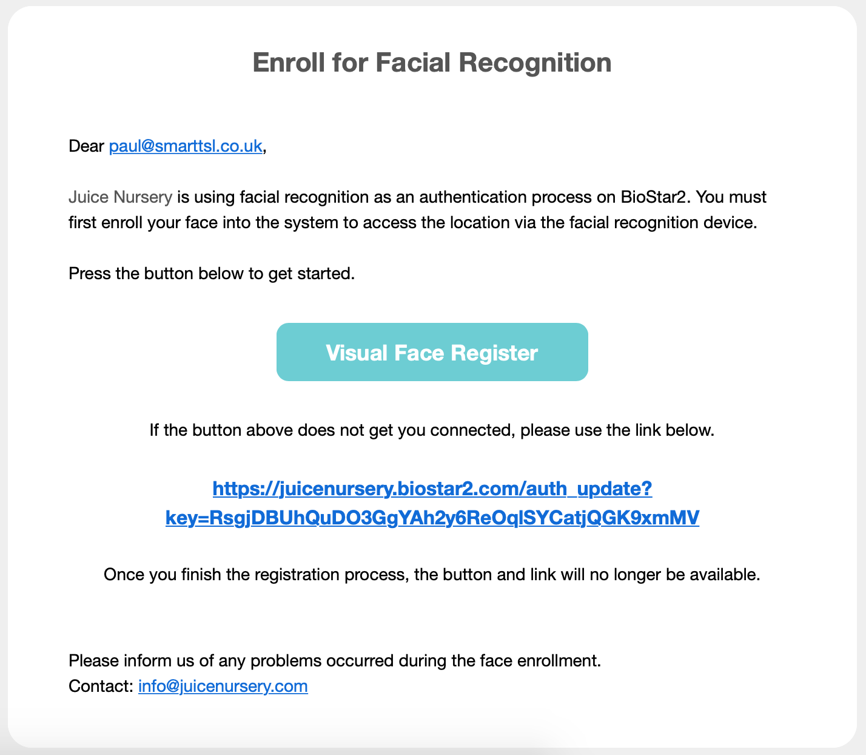

You will be taken to the registration page. Please click the “Register” button to continue.

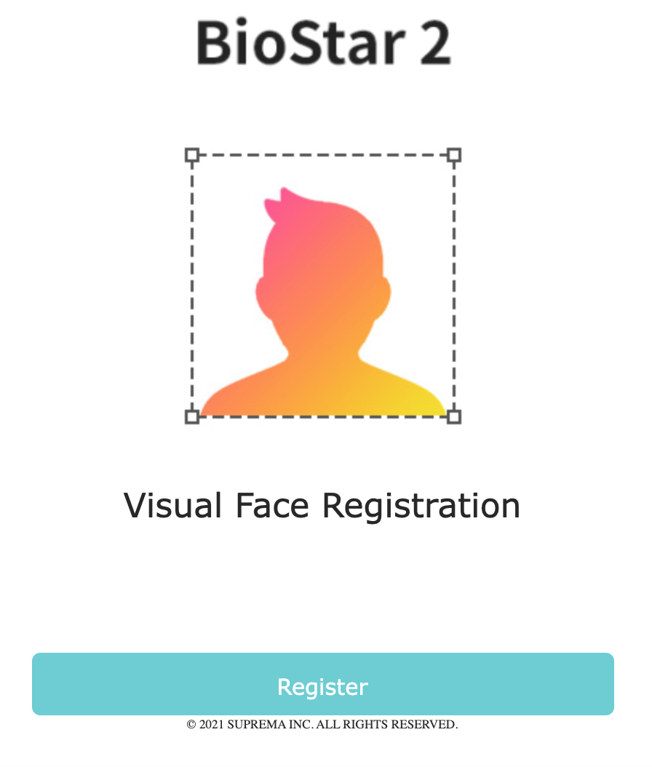

When asked, please agree to the terms & conditions, then click “Next”.

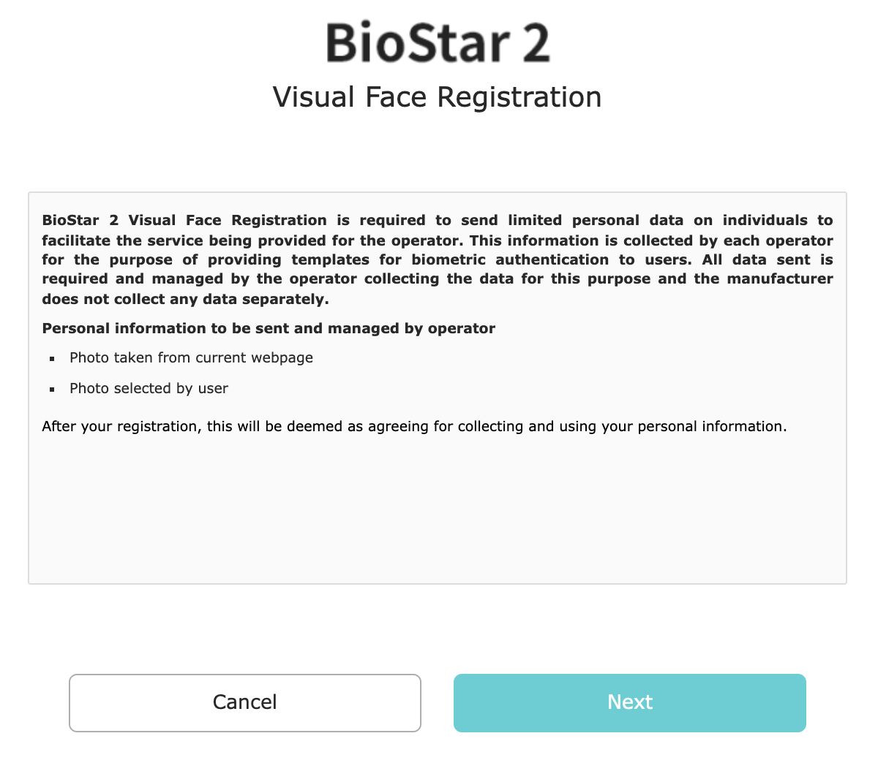
You will then be asked to take or upload a photograph. Please tap the example grid or click the “X” in the top-right of the grid to continue.

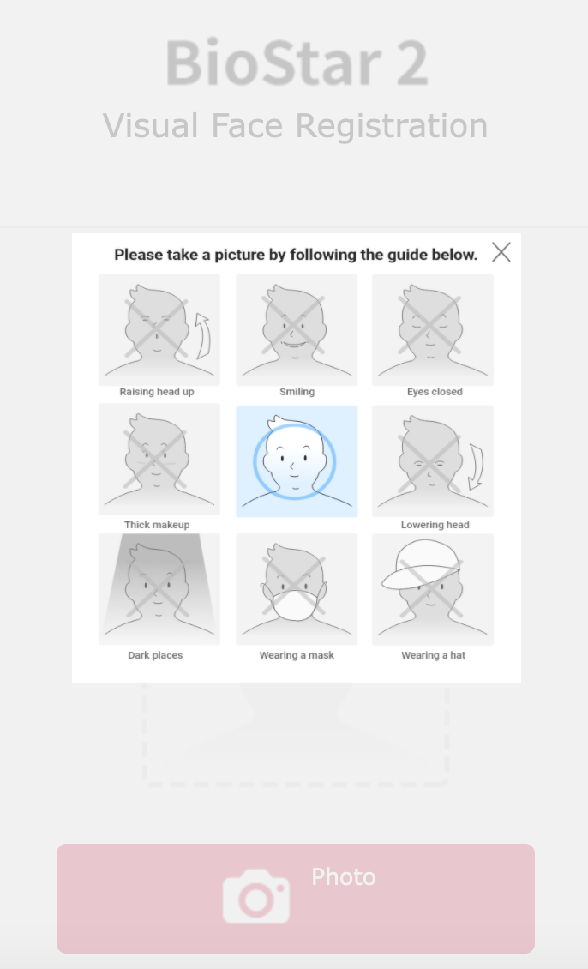
On this page, you can take or upload a photo by clicking the “Photo” button.

Follow the instructions to upload the photo. Once completed, check the image is clear and sharp like you would with a passport photograph. Then click the “Upload” button to complete the process.

